Lab 5 (Istio Setup)

By Sarah Martin

Student ID: C00257967

# 

**Download Istio** 2

**Open the Application to outside traffic** 3

**Determine the ingress IP and ports** 3

**Verify external Access** 4

**View the dashboard** 5

# 

# Download Istio

I began with installing the Istio release and added the istioctl client to my path (MacOs).

I then installed the demo configuration profile.

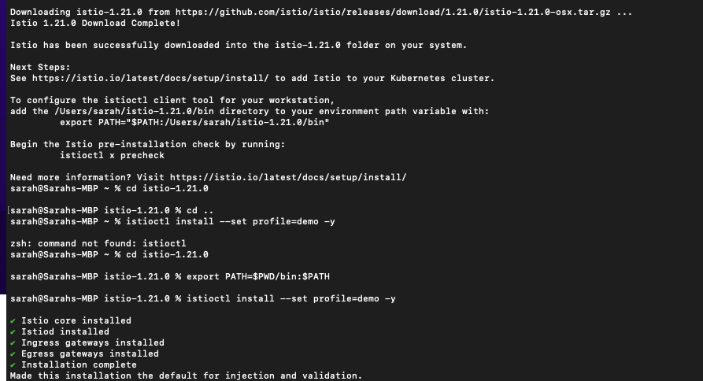

I added a namespace label to Istio. 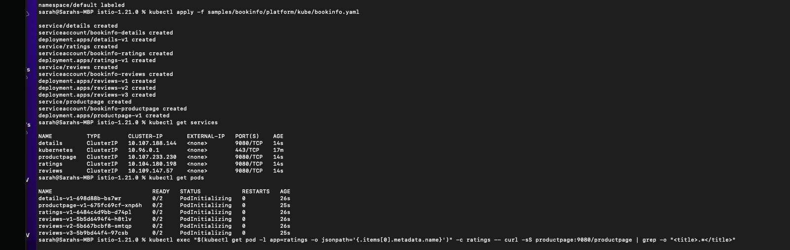

Deploy the sample application

I then deployed the Bookinfo sample application. I did a get services command and a get pods command. I then verified that everything was working correctly by running the Kubectl exec command.

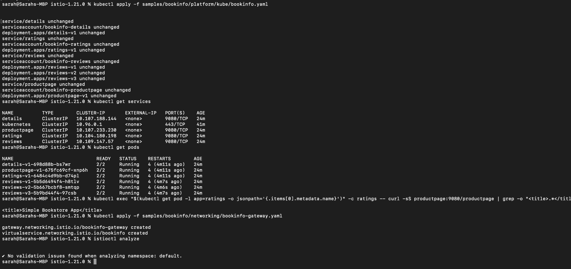

# Open the Application to outside traffic

I associated the application with the Istio gateway. I then did the “istioctl analyze” command to make sure there was no configuration issues.



# Determine the ingress IP and ports

I opened up a new terminal and ran the “minikube tunnel” command so it sends traffic to the Istio Ingress Gateway. I then set the ingress host and ports and then ensured that they were successfully assigned to each environment variable. I also set the Gateway_URL.

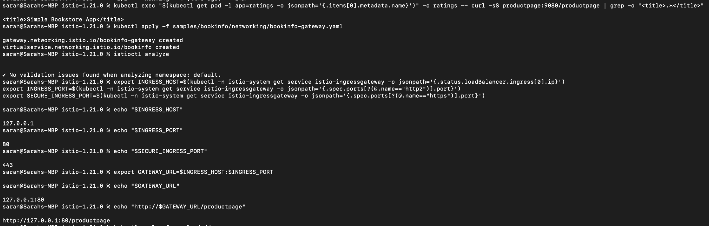

# Verify external Access

I ran the following command to get the external address of the Bookinfo application and pasted the url into my web browser.



# 

# 

# View the dashboard

I installed the Kiall and other addons and waited for them to be deployed.

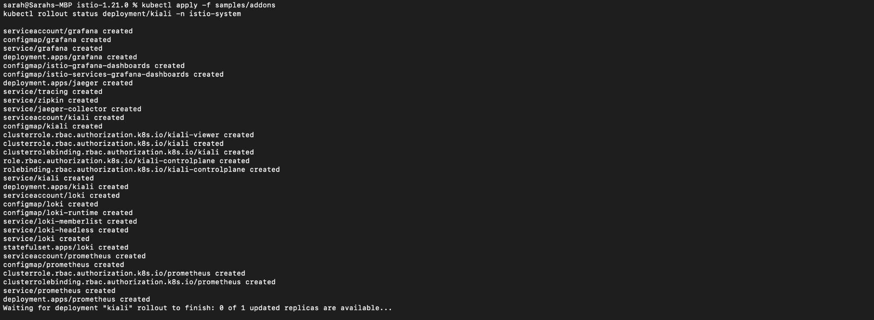

I then accessed the dashboard to view it.



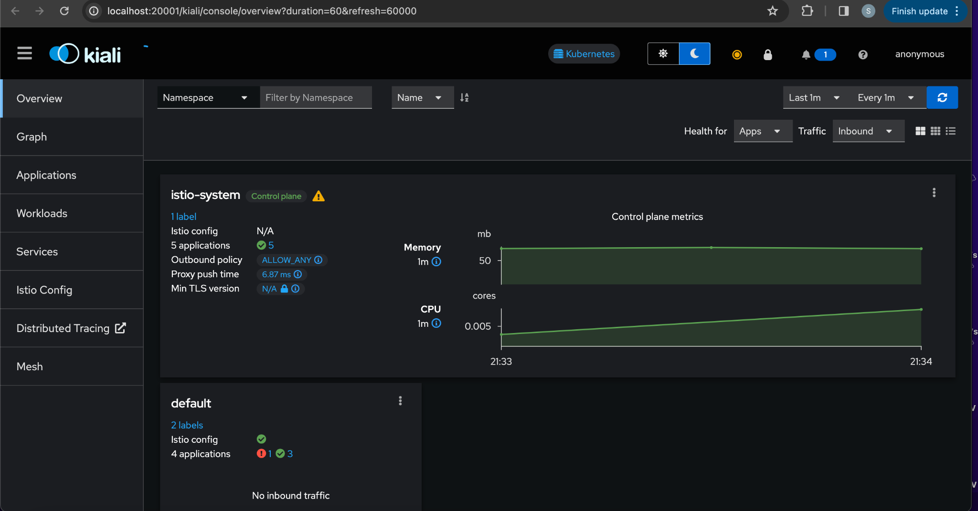

I ran this command to view the graph.

